**Information System Management Lab**

**BCOM 307**

**Assignment #21**

***Submitted by:***

**Name:** YASH JAIN

**Enrollment No:** 03914788818

**Semester:** B.Com(H) 5th Semester

**Class:** B.COM(H)

**Section:** B.Com 5A

**Date of Submission:** 25/10/2021

***Submitted to:***

**Praveen Kumar Singh**

**Assistant Professor, MAIMS**



**Department of Commerce**

**Maharaja Agrasen Institute of Management Studies**

**Affiliated to Guru Gobind Singh Indraprastha University, Delhi**

**Sector -22, Rohini, Delhi -110086, India; www.maims.ac.in**

Maharaja Agrasen Institute of Management Studies

Affiliated to GGS IP University; Recognized u/s 2(f) of UGC Recognized by Bar Council ofIndia; ISO 9001: 2015

Certified Institution Sector 22, Rohini, Delhi -110086, India; [www.maims.ac.in](http://www.maims.ac.in/)

Department of Commerce

Academic Year: 2020-21

Semester: Vth

# Assignment No. 21

# Unit No:

**Course/Subject Code:** BCOM 307 **Subject Title: Information System Management Lab**

# Issue Date Last Date of Submission:

**Instructions for Students:**

# All Questions are Compulsory.

1. The student should attach proper cover page for each assignment clearly mentioning the Assignment No.
2. Each assignment should be prepared by the student individually with proper explaination and screenshots.
3. A4 size ruled sheets should be used for the assignment.
4. Assignment pages should be serially numbered at the bottom of page.

***During online education mode, upload scanned copy of the complete assignment including cover page latest by due date.***

|  |  |  |
| --- | --- | --- |
| **Question No.** | **Question** | **CO No.** |
| 1 | Display all of the information of the employees whose salary is within the range of smallest value and 2500. | **CO2, CO3, CO4, CO5** |
| 2 | Display the number of employees in each department with their department number. |
| 3 | Display employee name, ID and Job Title of all employees with location Delhi. |
| 4 | Write sql command to display the name and job title for all employees whose salary is more than average salary of all employees. |
| 5 | Add a new column 'Location' in the employee table with values. |

**ASSIGNMENT 21 - SQL SUB-QUERIES PRACTICE**

**Task 1 : Display all of the information of the employees whose salary is within the range of smallest value and 2500.**

This task can be completed using the **SQL Sub-queries** used with the **BETWEEN** Clause.

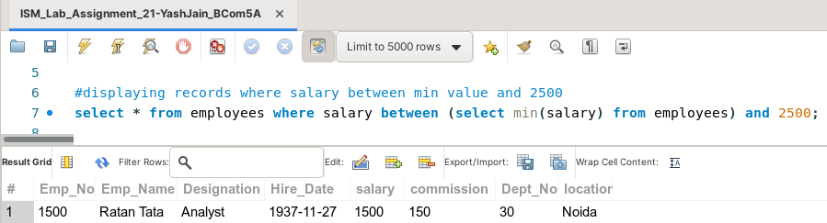

**Task 2: Display the number of employees in each department with their department number.**

This task can be completed using the **COUNT( ) Aggregate function** and **GROUP BY** clause.

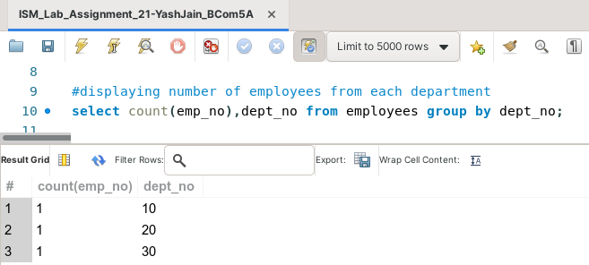

**Task 3: Display employee name, ID and Job Title of all employees with location Delhi.**

This task can be completed using the **WHERE** clause in the **Sub-Query.**

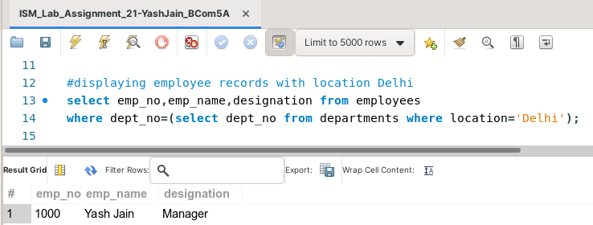

**Task 4: Write SQL command to display the name and job title for all employees whose salary is more than average salary of all employees.**

This task can be completed using the **AVG( )** aggregate function in the **Sub-Query.**

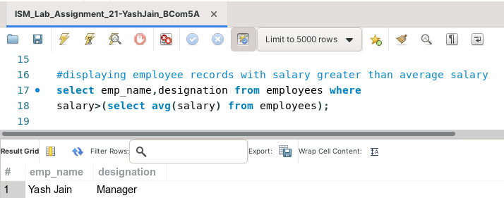

**Task 5: Add a new column 'Location' in the employee table with values.**

This task can be completed using the **ALTER and UPDATE Commands.**

